MUSA5000

Assignment #2: OLS, Spatial Lag, Spatial Error, and Geographically Weighted Regressions

Akira Di Sandro, Sofia Fasullo, Amy Solano

Figures from GeoDa

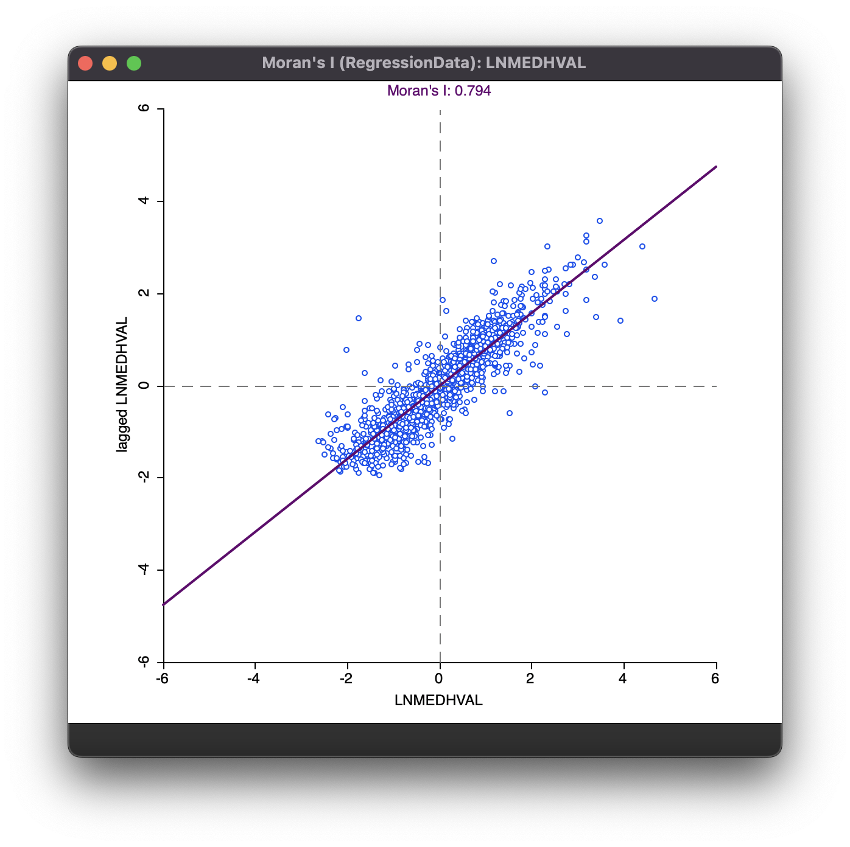

Scatter plot of Global Moran’s I of Median House Value (log-transformed; LNMEDHVAL)

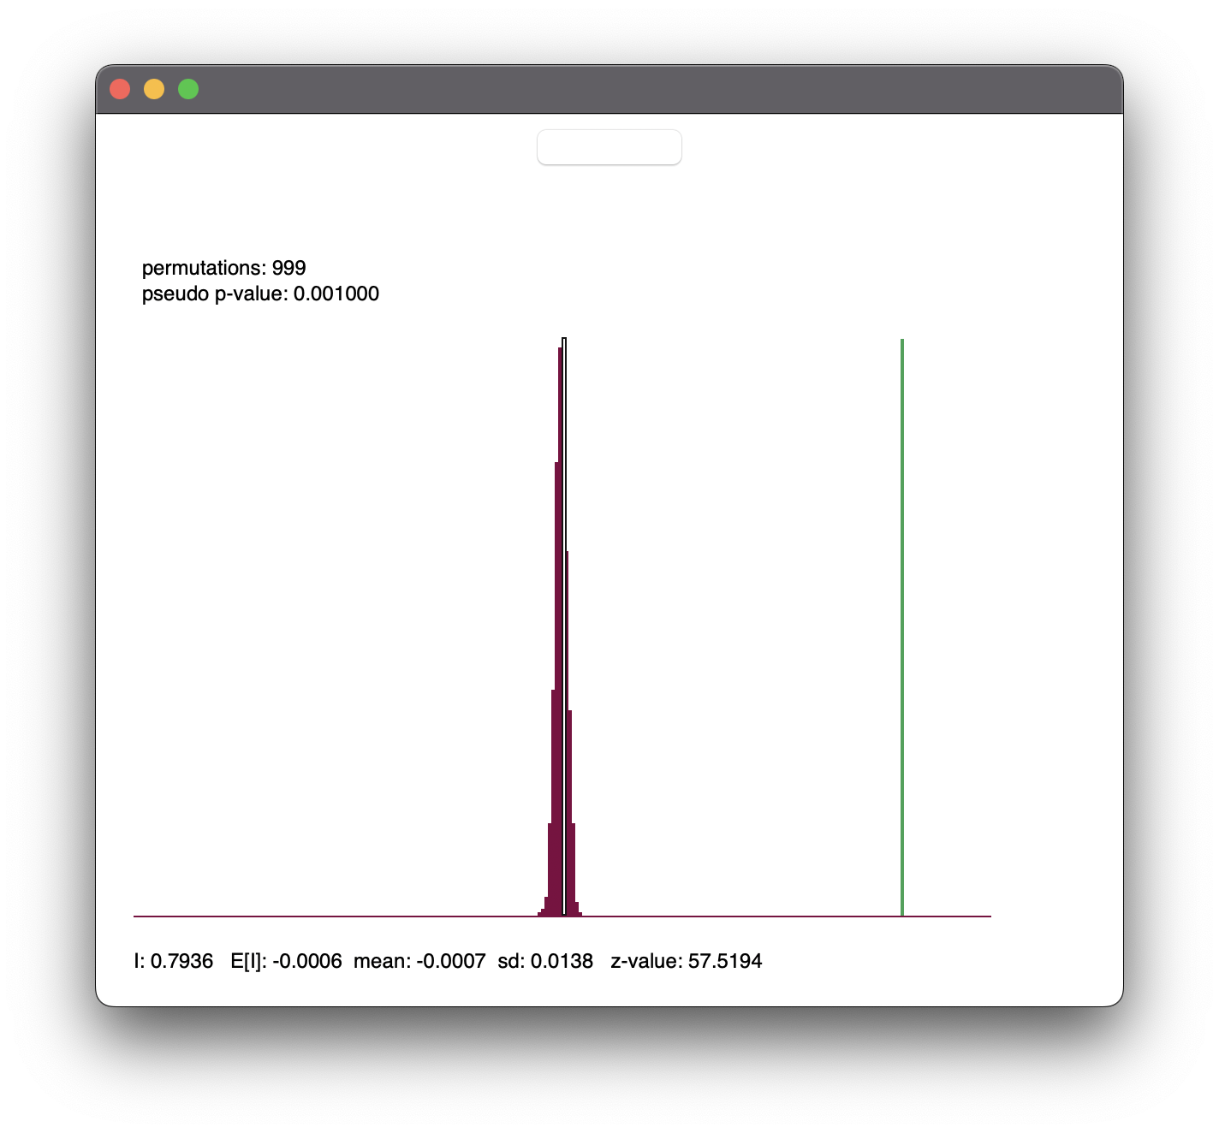

Random Permutations Test for Global Moran’s I of Median House Value (log-transformed; LNMEDHVAL)

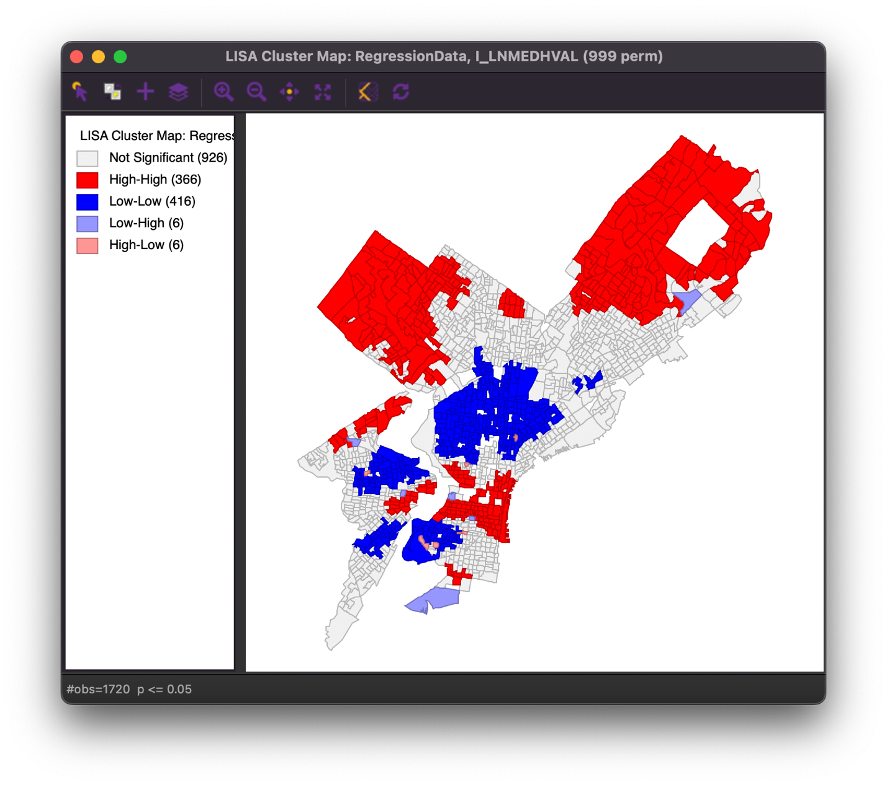

Local Moran’s I results for Median House Value (log-transformed; LNMEDHVAL)

Cluster Map

Local Moran’s I results for Median House Value (log-transformed; LNMEDHVAL)

Significance Map

SUMMARY OF OUTPUT: ORDINARY LEAST SQUARES ESTIMATION

Data set : RegressionData

Dependent Variable : LNMEDHVAL Number of Observations: 1720

Mean dependent var : 10.882 Number of Variables : 5

S.D. dependent var : 0.62972 Degrees of Freedom : 1715

R-squared : 0.662300 F-statistic : 840.869

Adjusted R-squared : 0.661513 Prob(F-statistic) : 0

Sum squared residual: 230.332 Log likelihood : -711.493

Sigma-square : 0.134304 Akaike info criterion : 1432.99

S.E. of regression : 0.366475 Schwarz criterion : 1460.24

Sigma-square ML : 0.133914

S.E of regression ML: 0.365942

-----------------------------------------------------------------------------

Variable Coefficient Std.Error t-Statistic Probability

-----------------------------------------------------------------------------

CONSTANT 11.1138 0.0465318 238.843 0.00000

PCTBACHMOR 0.0209095 0.000543184 38.4944 0.00000

PCTVACANT -0.0191563 0.000977851 -19.5902 0.00000

PCTSINGLES 0.00297695 0.000703155 4.23371 0.00002

LNNBELPOV -0.0789035 0.0084567 -9.3303 0.00000

-----------------------------------------------------------------------------

REGRESSION DIAGNOSTICS

MULTICOLLINEARITY CONDITION NUMBER 12.990609

TEST ON NORMALITY OF ERRORS

TEST DF VALUE PROB

Jarque-Bera 2 778.9646 0.00000

DIAGNOSTICS FOR HETEROSKEDASTICITY

RANDOM COEFFICIENTS

TEST DF VALUE PROB

Breusch-Pagan test 4 162.9108 0.00000

Koenker-Bassett test 4 61.6992 0.00000

SPECIFICATION ROBUST TEST

TEST DF VALUE PROB

White 14 111.3224 0.00000

DIAGNOSTICS FOR SPATIAL DEPENDENCE

FOR WEIGHT MATRIX : RegressionData

(row-standardized weights)

TEST MI/DF VALUE PROB

Moran's I (error) 0.3129 22.3664 0.00000

Lagrange Multiplier (lag) 1 930.1626 0.00000

Robust LM (lag) 1 441.1061 0.00000

Lagrange Multiplier (error) 1 490.5691 0.00000

Robust LM (error) 1 1.5126 0.21875

Lagrange Multiplier (SARMA) 2 931.6751 0.00000

Scatter plot of OLS_RESIDU and WT_RESIDU

Scatter plot of Global Moran’s I of OLS_RESIDU

Random Permutations Test for Global Moran’s I of OLS_RESIDU

SUMMARY OF OUTPUT: SPATIAL LAG MODEL - MAXIMUM LIKELIHOOD ESTIMATION

Data set : HW02_RegressionData

Spatial Weight : HW02_RegressionData

Dependent Variable : LNMEDHVAL Number of Observations: 1720

Mean dependent var : 10.882 Number of Variables : 6

S.D. dependent var : 0.62972 Degrees of Freedom : 1714

Lag coeff. (Rho) : 0.651097

R-squared : 0.818564 Log likelihood : -255.74

Sq. Correlation : - Akaike info criterion : 523.48

Sigma-square : 0.071948 Schwarz criterion : 556.18

S.E of regression : 0.268231

-----------------------------------------------------------------------------

Variable Coefficient Std.Error z-value Probability

-----------------------------------------------------------------------------

W_LNMEDHVAL 0.651097 0.0180501 36.0716 0.00000

CONSTANT 3.89846 0.201114 19.3843 0.00000

PCTBACHMOR 0.00851381 0.000521935 16.312 0.00000

PCTVACANT -0.0085294 0.000743667 -11.4694 0.00000

PCTSINGLES 0.00203342 0.00051577 3.9425 0.00008

LNNBELPOV -0.0340547 0.00629287 -5.41163 0.00000

-----------------------------------------------------------------------------

REGRESSION DIAGNOSTICS

DIAGNOSTICS FOR HETEROSKEDASTICITY

RANDOM COEFFICIENTS

TEST DF VALUE PROB

Breusch-Pagan test 4 220.3884 0.00000

DIAGNOSTICS FOR SPATIAL DEPENDENCE

SPATIAL LAG DEPENDENCE FOR WEIGHT MATRIX : HW02_RegressionData

TEST DF VALUE PROB

Likelihood Ratio Test 1 911.5067 0.00000

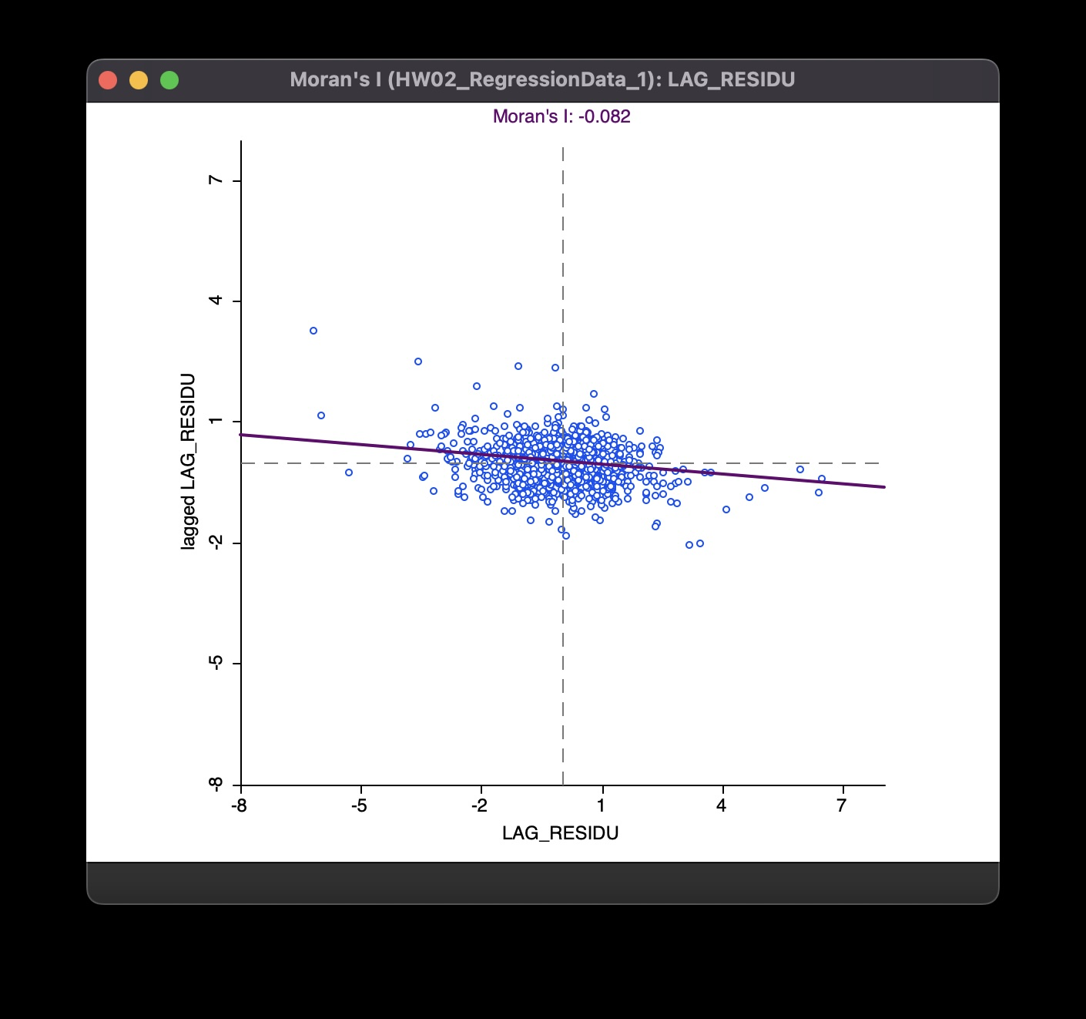

Scatter plot of Global Moran’s I of LAG_RESIDU

Random Permutations Test of Global Moran’s I of LAG_RESIDU

SUMMARY OF OUTPUT: SPATIAL ERROR MODEL - MAXIMUM LIKELIHOOD ESTIMATION

Data set : HW02_RegressionData

Spatial Weight : HW02_RegressionData

Dependent Variable : LNMEDHVAL Number of Observations: 1720

Mean dependent var : 10.882000 Number of Variables : 5

S.D. dependent var : 0.629720 Degrees of Freedom : 1715

Lag coeff. (Lambda) : 0.814918

R-squared : 0.806957 R-squared (BUSE) : -

Sq. Correlation : - Log likelihood : -372.690368

Sigma-square : 0.0765508 Akaike info criterion : 755.381

S.E of regression : 0.276678 Schwarz criterion : 782.631

-----------------------------------------------------------------------------

Variable Coefficient Std.Error z-value Probability

-----------------------------------------------------------------------------

CONSTANT 10.9064 0.0534678 203.981 0.00000

PCTBACHMOR 0.00981293 0.000728964 13.4615 0.00000

PCTVACANT -0.00578308 0.000886701 -6.52201 0.00000

PCTSINGLES 0.00267792 0.000620832 4.31343 0.00002

LNNBELPOV -0.0345341 0.00708933 -4.87127 0.00000

LAMBDA 0.814918 0.016373 49.7719 0.00000

-----------------------------------------------------------------------------

REGRESSION DIAGNOSTICS

DIAGNOSTICS FOR HETEROSKEDASTICITY

RANDOM COEFFICIENTS

TEST DF VALUE PROB

Breusch-Pagan test 4 210.9923 0.00000

DIAGNOSTICS FOR SPATIAL DEPENDENCE

SPATIAL ERROR DEPENDENCE FOR WEIGHT MATRIX : HW02_RegressionData

TEST DF VALUE PROB

Likelihood Ratio Test 1 677.6059 0.00000

Scatter Plot of Global Moran’s I of ERR_RESIDU

Random Permutations Test of Global Moran’s I of ERR_RESIDU

Scatter Plot of Global Moran’s I of GWR_RESIDU

Random Permutations Test of Global Moran’s I of GWR_RESIDU